**Practical No. 5**

**Aim :** Study of Grid Sim.

**Performed By :** Kaveri War

**Class :** BCA-III SEM-VI

**Date :** 04/02/2025

* **Introduction**

 “**GridSim** is a Java-based discrete-event grid simulation toolkit that models and simulates distributed resource management and scheduling for grid computing.”

GridSim is a simulation toolkit designed for modeling and simulating grid computing environments. It provides a framework for researchers and developers to study various aspects of grid computing, including resource management, scheduling, and performance evaluation. While GridSim is primarily focused on grid computing, it can also be applied to cloud computing scenarios due to the similarities between the two paradigms.

### Key Features of GridSim :

1. **Resource Modeling**: GridSim allows users to model various types of resources, including computational nodes, storage, and network resources. This is essential for simulating the behavior of grid and cloud environments.
2. **User and Resource Management**: The toolkit supports the modeling of users, their resource requirements, and the management of resources. This includes job submission, resource allocation, and monitoring.
3. **Scheduling Algorithms**: GridSim provides a platform to implement and test different scheduling algorithms. Researchers can evaluate how different strategies affect performance metrics such as job completion time, resource utilization, and overall system throughput.
4. **Network Simulation**: The toolkit includes features for simulating network characteristics, which is crucial for understanding the impact of network latency and bandwidth on grid and cloud applications.
5. **Extensibility**: GridSim is designed to be extensible, allowing users to add new features or modify existing ones to suit their specific research needs.
6. **Performance Metrics**: Users can collect various performance metrics during simulations, such as execution time, waiting time, and resource utilization, which are essential for evaluating the effectiveness of different configurations and algorithms.

### Types of Simulations in GridSim :

1. **Resource Allocation Simulations**: These simulations focus on how resources are allocated to different tasks or users. Researchers can study the impact of different allocation strategies on performance.
2. **Scheduling Simulations**: This involves testing various scheduling algorithms to determine which one performs best under different conditions, such as varying workloads or resource availability.
3. **Load Balancing Simulations**: Load balancing is crucial in grid and cloud environments to ensure that no single resource is overwhelmed while others are underutilized. Simulations can help identify effective load balancing strategies.
4. **Performance Evaluation**: Researchers can use GridSim to evaluate the performance of grid and cloud applications under different configurations, including varying resource types, network conditions, and user demands.
5. **Fault Tolerance and Reliability**: Simulations can also be conducted to study how systems respond to failures and how fault tolerance mechanisms can be implemented to improve reliability.

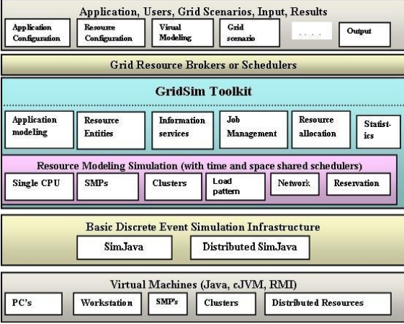

### Architecture of GridSim :

GridSim's architecture consists of several key components:

1. **Grid Resource**: Represents the computational resources available in the grid, such as CPUs, storage, and network bandwidth.
2. **Grid User**: Represents the users who submit jobs to the grid. Users can have different resource requirements and priorities.
3. **Job**: Represents the tasks submitted by users. Each job can have specific resource requirements and execution characteristics.
4. **Scheduler**: Responsible for allocating resources to jobs based on scheduling algorithms. It determines which job gets which resources and when.
5. **Network**: Simulates the communication between resources and users, including latency and bandwidth constraints.
6. **Simulation Engine**: The core component that manages the simulation process, including event scheduling and execution.

### Applications of GridSim in Cloud Computing :

While GridSim is primarily designed for grid computing, its features can be applied to cloud computing scenarios, such as:

* **Cloud Resource Management**: Simulating how cloud resources are managed and allocated to users based on demand and availability.
* **Service Level Agreements (SLAs)**: Evaluating how different scheduling and resource allocation strategies can meet SLAs in cloud environments.
* **Cost Analysis**: Studying the cost implications of different resource management strategies in cloud computing.
* **Hybrid Environments**: Investigating the interaction between grid and cloud resources in hybrid computing environments.

### Conclusion :

GridSim is a powerful tool for simulating and studying grid and cloud computing environments. Its flexibility and extensibility make it suitable for a wide range of research applications, from resource management to performance evaluation.

By leveraging GridSim, researchers can gain valuable insights into the behavior of grid and cloud systems, ultimately contributing to the development of more efficient and effective computing solutions.